**FAKE PRODUCT IDENTIFICATION SYSTEM**

**Introduction**

Counterfeit goods have become a global problem as consumers are being deceived into buying unauthentic goods with no way to validate the authenticity. Recently, blockchain has become more popular as it fosters trust between untrusting participants. This paper uses blockchain technology to combat the sale of counterfeit products. We use blockchain to allow manufacturers to add authentic product serial numbers onto the ledger; consumers can then use the serial number to verify the authenticity of a product before purchasing it. Blockchain plays a pivotal role in ensuring that data was not tampered with - creating a trusted environment.

**Motivation**

There In recent years, the spread of counterfeit goods has become global. There are many fake products in the current supply chain. According to the report, fake product incidents have risen in the last few years. It is necessary to have a system for customers or users to check the all details of the product so that users can decide that the product is real or fake. In India currently, there is no such system to detect counterfeit products. So, the solution involves a simple QR code-based identification that can help the end-user or customers to scan and identify the genuineness of the product by using a smartphone.

**Objective and scope**

The idea of this project came into existence because of the increase in the counterfeit products. The objectives of this project are:

* To Design Anti Counterfeit System using Blockchain.
* To secure product details using a QR code.
* Provide security to the clients by offering data to client.

In future, with the help of machine learning algorithms & blockchain together can be used to classify marks and logos and detect text with the help of OCR. This would combine three state-of-the-art technologies, machine learning, Text recognition and web searching in one application.

**System Surveys**

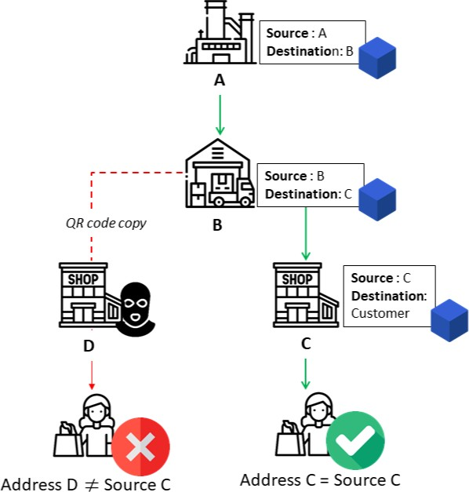

The main aim of this proposed system is to maintain the Genuity of the product by helping the customer track the supply chain history of the product. System give customers the power to track the history of an entire product from manufacturer to customer using blockchain. This product anti-counterfeiting system based on Blockchain is composed of three roles, the Manufacturer role, the Seller role, and the Consumer role. The process of detecting a counterfeit product by the customer while is shown in figure.

## Problem Statement

The overall improvement of a thing or development reliably goes with danger factors, for instance, producing and duplication. Manufacturing things can impact the association's name and the customer's prosperity. As of now days revelation of fake thing is the best test. Counterfeit things are causing a critical effect on the association and the customer's prosperity. Consequently, thing makers are defying tremendous adversity.

India and various countries are doing combating such phony and phony things. In the proposed structure, the system produces secret key codes using Blockchain advancement. This advancement stores trade records in blocks. These squares are secure and hard to access and change the information from it. By using a secret key code, we can perceive the phony thing.

**Discussion**

The proposed system allows both manufacturers and sup- pliers to interact with the system to add their respective block containing the transaction details to blockchain without modifying other’s block. The contracts for the manufacturer and supplier block are written using solidity. Since the code is running on local network ganache have been used for local testing. The interface is created using React.

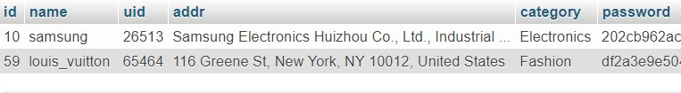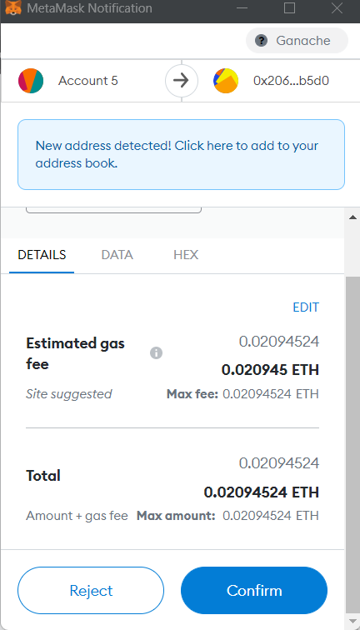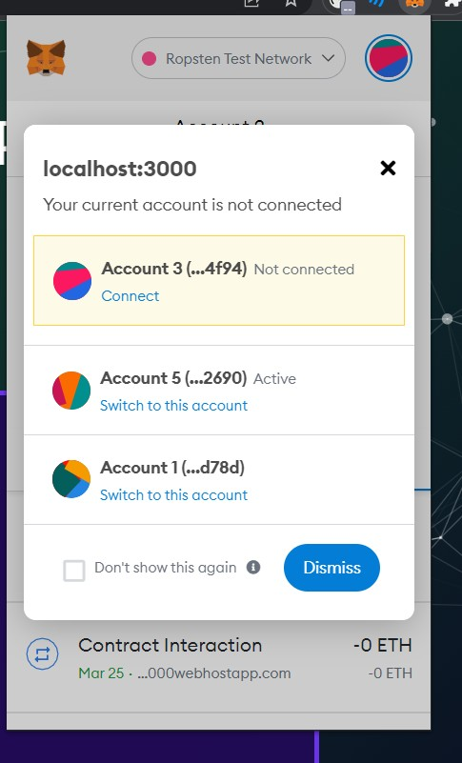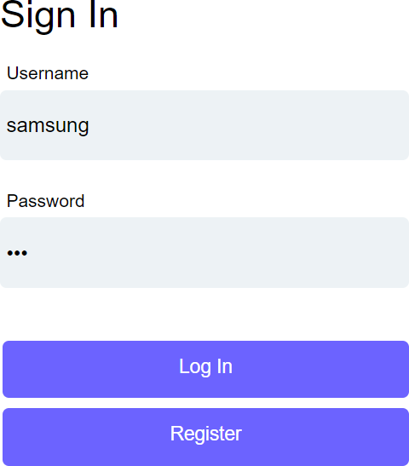Connecting to Ethereum using Metamask wallet :

The credentials are stored in SQL server as shown in Figure SQL database is used for storing manufacturer and supplier login details and their address.

Once confirmed the block containing all details are added to blockchain and success page is displayed as shown in Figure .

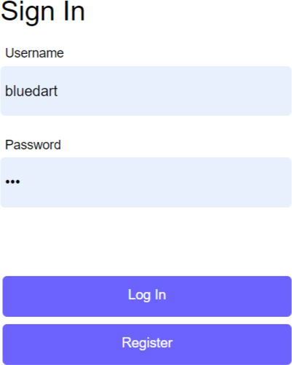Message after addition of block to blockchain. Manufacturer Login page

Other supplier involved similarly log into their account and adds their respective blocks to the blockchain. After the product reaches the customer he can visit the customer page scan the QR code as shown in Figure and check the complete supply chain history of product

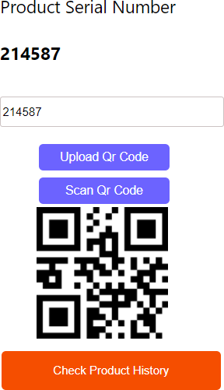

 Message after addition of block to blockchain. Further system can be extended to avoid frauds done in banking, healthcare, voting system, online shopping and so on.

## Requirement Specification

**ECLIPSE IDE FOR JAVA DEVELOPMENT**

In computer programming Eclipse plays an important role. It is an integrated development environment (IDE) contains workspace and huge extensible plug-in for designing the environment. It is usually written in java programming and basic use to develop java-based applications, also used to develop various applications of other programming languages like Ada, C, C++, C#, COBOL, PHP, Python etc. The initial eclipse codebase originated from IBM VisualAge. It is a software development tool kit contains various packages. Eclipse [8] was one of the IDEs to run under GNU Classpath.



## SQLYOG

SQLyog is a graphical user interface tool for RDBMS MYSQL and it is developed Webyog [9][10]. It can be distributed both as free software as well as paid versions. The important features of SQLyog includes

## 

* + - It can perform various formatting options and intelligent code completion
    - Data manipulation operations like INSERT, DELETE, UPDATE can be performed on Spreadsheet like interface.
    - Visual Schema Designer and Query formatting can be done.



**ANDROID STUDIO**

Android Studio is the official integrated development environment (IDE) for Googles Android operating system, built on IntelliJ IDEA software and designed especially for Android development. It is available for download on Windows, macOS and Linux based operating systems.



**FIREBASE CLOUD**

Firebase is a platform developed by Google for creating mobile and web applications. It was originally an independent company founded in 2011. In 2014, Google acquired the platform and it is now their flagship offering for app development.



**HARDWARE AND SOFTWARE REQUIREMENTS**

HARDWARE:

* Processor: Intel Core i3 or more.
* RAM: 4GB or more.
* Hard disk: 250 GB or more.

 SOFTWARE:

* Operating System : Windows 10, 7, 8.
* Python
* Anaconda
* Spyder, Jupyter notebook, Flask.
* MYSQL
* Android studio,JAVA
* Ganache

**Testing Technologies**

We will use the SHA-256 algorithm to generate a QR code in blockchain technology. generated The QR code is scanned by the user to check given product is fake or real. Counterfeit products are growing exponentially with the enormous amount online.

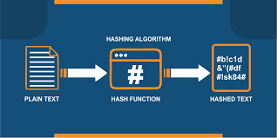

**Working Diagram**

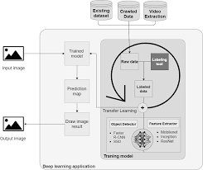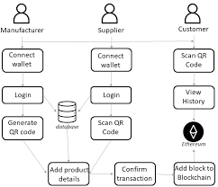

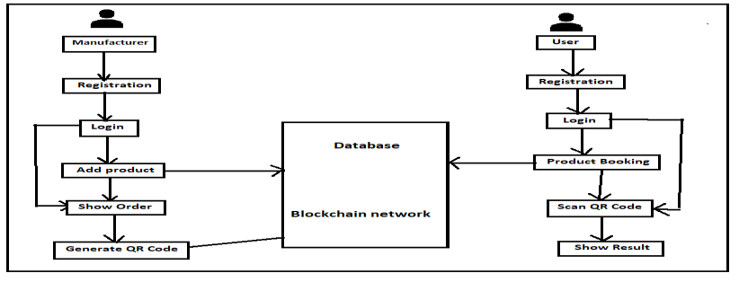

**Conclusion**

Digital information of products can be stored in the form of blocks in blockchain technology. The data can be stored in the firebase cloud. Thus, the proposed system is useful for the customer to detect fake products in the supply chain. Customers can scan QR codes assigned to a product and can get all the information

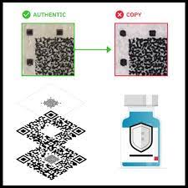

**RESULT**

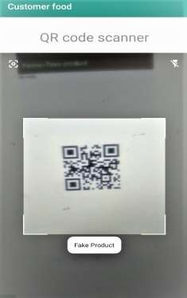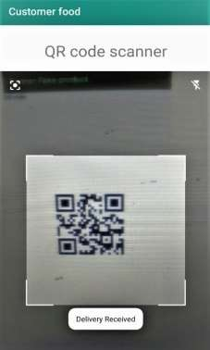This real-time system can be implemented to check the received product is a counterfeit product or original product. The manufacturer uses the SHA-256 algorithm to generate a QR code in blockchain technology. The generated QR code is scanned by the user to check given product is fake or real.

**Fake Product Detection Received Product**

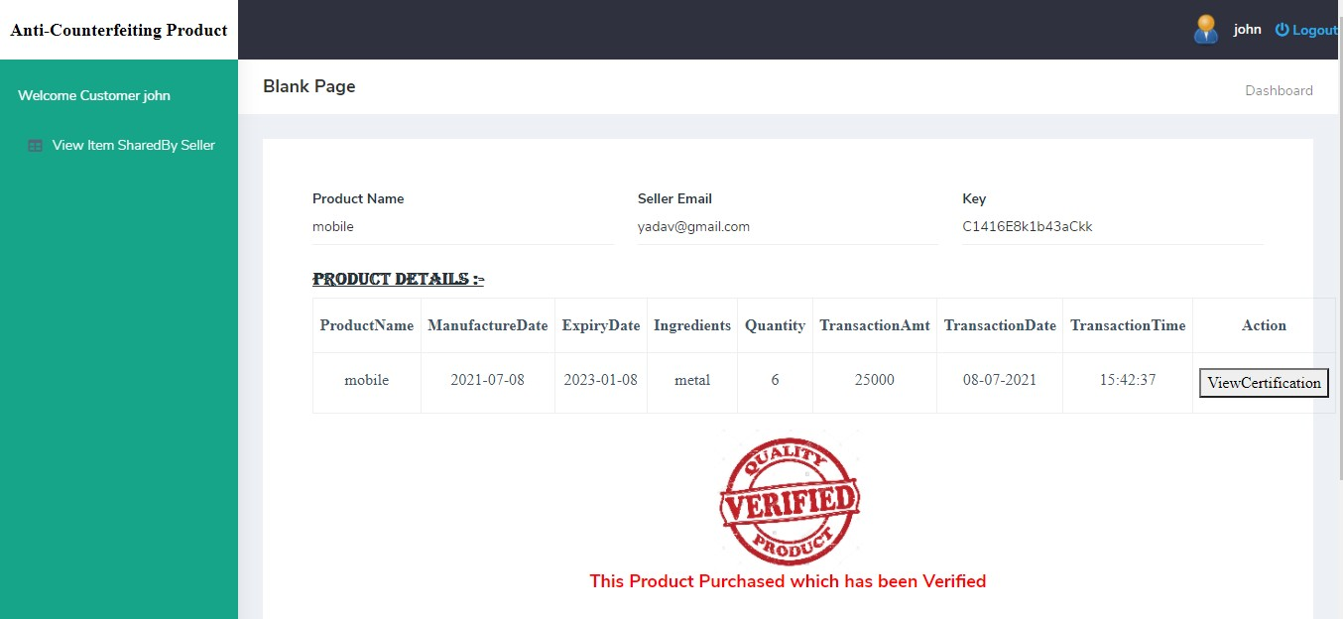

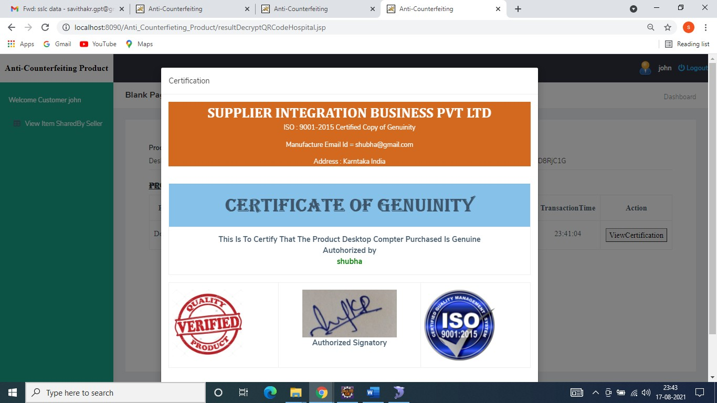

The continuous framework can be executed to check the product is a fake product or unique product. The producer utilizes the SHA-1 calculation to create a public key code in blockchain innovation. The created secret key code is examined by the customer to check given product is phony or genuine.

**REFERENCE**

[1] Si Chen, Rui Shi, Ren, Jiaqi Yan, Yani Shi, “A Blockchain-based Supply Chain Quality Management Framework”, 14th, IEEE International Conference on e-Business Engineering, 2017.

[2] Blockchain Based Fake Product Identification in Supply Chain www.irjet.net: Ajay Funde, Pranjal Nahar, Ashwini Khilari.

[3] Fake News Detection In Social Media using Blockchain: - Shovon Paul, Jubair Joy, Shaila Sarkar.

[4] A Blockchain-Based Application System for Product Anti-Counterfeiting (IEEE Access): Jinhua Ma, Xin Chen, hung-Min SuG. Vidhya Lakshmi, Subbarao Gogulamudi, Bodapati Nagaeswari, Shaik Reehana, “Blockchain Based Inventory Management by QR Code Using Open CV”, International Conference on Computer Communication and Informatics (ICCCI -2021) Coimbatore, INDIA, Jan. 27 – 29, 2021 Networks”, Proceedings of the Fourth International Conference on Inventive Systems and Control (ICISC 2020),2020.

[5]. Jinhua Ma, Shih-Ya Lin, Xin Chen, Hung-Min Sun, Yeh-Cheng Chen, and Huaxiong Wang, “A Blockchain-Based Application System for Product Anti- Counterfeiting”, IEEE Access,2020. [6]. Veneta Aleksieva, Hristo Valchanov and Anton Huliyan, “Implementation of Smart- Contract, Based on Hyperledger Fabric Blockchain”, International Symposium on Electrical Apparatus & Technologies (SIELA) - Bourgas, Bulgaria,2020.

[7]. Ajay Kumar Shrestha, Julita Vassileva “Bitcoin Blockchain Transactions Visualization” University of Saskatchewan Saskatoon, Canada, 2020.

[8]. Vinayak Singla, Indra Kumar Malav, Jaspreet Kaur and Sumit Kalra, “Develop Leave Application using Blockchain Smart Contract”, 11th international conference on Communication Systems and Networks,2019.

[9]. Jesus Maximo Montes, Cecilia E. Ramirez, Manuel Coronado Gutierrez, Victor M. Larios, “Smart Contracts for supply chain applicable to Smart Cities daily operations”5th IEEE International Smart Cities Conference (ISC2 2019), 2019.

[10]. Sanjay K. S, Dr. Ajit Danti “Detection of fake opinions on online products using Decision Tree and Information Gain” Third International Conference on Computing Methodologies and Communication (ICCMC 2019),2019.

[11]. Mario Tomisa, Marin Milkovic, Marko Cacic, “Performance Evaluation of Dynamic and Static WordPress-based Websites”, IEEE Access 2019.

[12]. Sidra Malik, Volkan Dedeoglu, Salil S. Kanhere, and Raja Jurdak, “TrustChain: Trust Management in Blockchain and IoT supported Supply Chains”, 9 IEEE International Conference on Blockchain (Blockchain),2019.

[13]. Steven Sandi, Sanja Radonjic, Jovana Drobnjak, Marko Simeunovic, Biljana Stamatovic and Tomo Popovic “Smart Tags for Brand Protection and Anti-counterfeiting in wine Industry” 23rd International Scientific-Professional Conference on Information Technology (IT), 2018.

[14]. Abhijeet Mendh, Mr. Deepak Kumar Gupta, Dr. Krishna Pal Sharma, “Secure QR-Code Based Message Sharing System Using Cryptography and Steganography”, First International Conference on Secure Cyber Computing and Communication (ICSCCC),2018.

[15]. Mayur M Patil “A qualitative analysis of the performance of MongoDB vs MySQL Database based on insertion and retrieval operations using a web/android application to explore Load Balancing – Sharding in MongoDB and its advantages” International conference on I-SMAC (IoT in Social, Mobile, Analytics and Cloud) (I-SMAC 2017),2017.

[16]. Ningning Yi, Xin Feng, Chunfang Li, “The Design and Implementation of the Front End of the Art Play Library System”, 7th International Conference on Communication Systems and Network Technologies,2017.

[17]. G. Sri Harsha Vardhan, Naveen Sivadasan, Ashudeb Dutta, “QR-Code based Chipless RFID System for Unique Identification”, IEEE International Conference on RFID Technology and Applications, 2016.

[18]. Bo Ya, Guangwen Huang, “Application of RFID and Internet of Things in Monitoring and Anti-counterfeiting for Products”, International Seminar on Business and Information Management,2016.

[19]. Mark A. Holliday and Andrew S. Scott “A Software Development Course Based on Server-Side JavaScript” Dept. of Mathematics and Computer Science Western Carolina University,2016. [20]. Leeladevi B, Pinku Hazarika and Hemadri Pavan Kumar Nanyam “Transforming a website from desktop to mobile: A cross platform viewpoint” Siemens Technology and Services Bangalore, India,2015[21] Saksham Aggarwal “A Blocks-Based Editor for HTML Code” International Institute of Information Technology Hyderabad, India,2015.